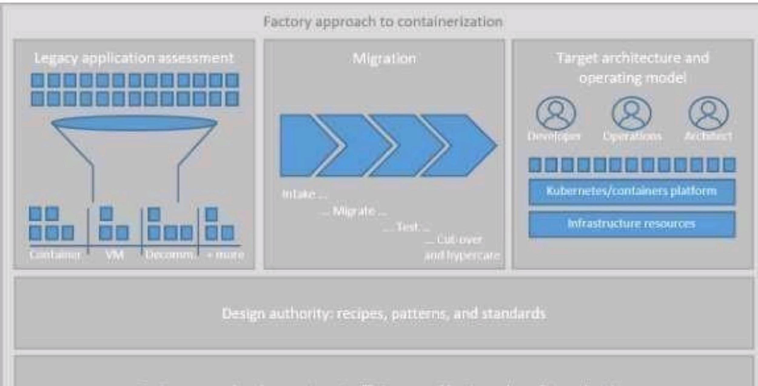CONTAINERIZE THE APP

|  |  |
| --- | --- |
| Date | 19 November 2022 |
| Team ID | PNT2022TMID07486 |
| Project Name | Nutrition Assistant Application |

